2.2

Vedi DD (2.3) → lista dei moduli nei componenti

2.3

For the integration test of the modules inside components we have chosen to use a “Big Bang” approach that allows us to test the interaction between the modules of a specific component when they are all developed. We thought this was acceptable because of the small number of modules in each component. We also made this choice because in most cases modules are “interfaces” towards other components so their interaction is tested during integration test of components.

2.4

Client Tier
Central Messenger
- [A1] A module that interfaces with GUI;
- [A2] A module that interfaces with GPS Reader;
- [A3] A module that interfaces with Server Central Messenger;
- [A4] A module that handles and forwards messages to modules.
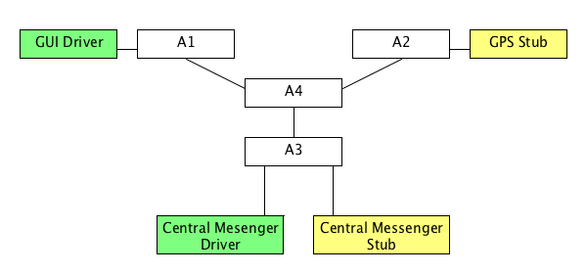

GPS Reader

- [B1] A module that interfaces with Central Messenger in order to receive re- quests and send information;
- [B2 ] A module that reads GPS information from Mobile APIs.

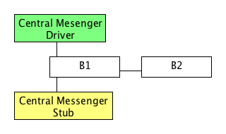
Graphical User Interface
- [C1] A module that interfaces with Central Messenger in order to receive and send messages;
- [C2] A module that shows navigation pages and collects user’s commands.
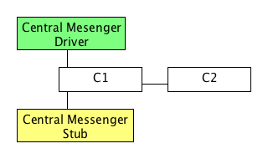
Web Tier
Central Messenger
- [D1] A module that interfaces with Queue handler;
- [D2] A module that interfaces with Request Allocator;
- [D3] A module that interfaces with Request Gatherer;
- [D4] A module that interfaces with Coverage Manager;
- [D5] A module that interfaces with Sign Up/Log In manager;
- [D6] A module that interfaces with Client Central Messenger;
- [D7] A module that interfaces with Client Browser;
- [D8] A module that handles and forward messages throw modules.
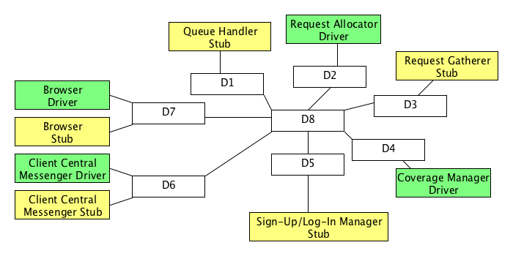
Business Tier
Sign Up Manager
- [E1] A Communication module that interfaces with Central Messenger;
- [E2] An Analysis module that, reading form Data module, analyses the correct- ness of data and it eventually confirms or rejects;
- [E3] A Data module that stores data in the correct database and read needed information.
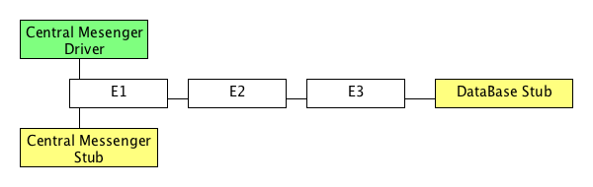
Coverage Manager
- [F1] A Data module that interfaces with databases making DBMS queries;
- [F2] An Analysis module that analyses information received from Data module and calculates the best coverage;
- [F3] A Communication module that interfaces with Central Messenger in order to send messages to Taxi Drivers selected by Analysis module.
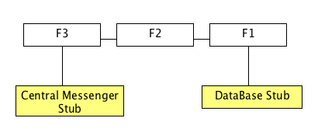
Request Gatherer
- [G1] A Communication module that receives requests messages from Central Messenger;
- [G2] An Analysis Module that analyses data integrity and requests information received from Communication module and eventually it sends to Data Module;
- [G3] A Data Module that stores information interfacing with databases.
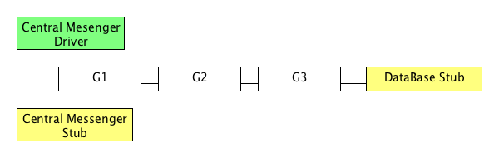
Request Allocator
- [H1] A Data Module that, periodically reading from databases, controls if there are requests to fulfil and updates taxi drivers’ information;
- [H2] An Analysis module that choses taxi diver to allocate to the requests;
- [H3] A Communication module that interfaces with Central Messenger in order to send notifications to taxi drivers.
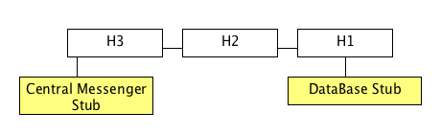
Queue Handler
- [I1] A Communication module that receives availability messages from Central Messenger;
- [I2] A Data module that store and updates information in database

